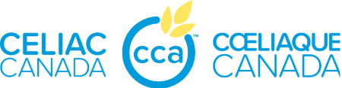
Celiac Disease – Teacher Quick-Glance Checklist
Student Name: __________________________
Gluten = Unsafe
Avoid ALL:
- Wheat
- Barley
- Rye
- Oats (unless labelled gluten-free)
- Triticale
DO:
✅ Check every food label, every time
✅ Give advance notice for class parties/events
✅ Offer naturally gluten-free foods (fresh fruits/veggies)
✅ Keep parent-provided safe snacks in a designated spot
✅ Allow immediate washroom breaks if needed
DON’T:
❌ Offer unlabelled food
❌ Use products with “may contain” wheat/barley/rye
❌ Allow food sharing
❌ Accept homemade food from other families

Other Safety Reminders
- Watch for gluten in craft supplies (Playdough, some glues)
- Encourage frequent handwashing
- Address food bullying immediately
- Respect privacy if the student needs to talk about food or symptoms

Questions? Not sure? Don’t serve it — ask the parent first.
Parent Contact: _______________________________
Phone: ______________________
More info: www.celiac.ca

